

|  |  |
| --- | --- |
| Indian Academy of Sciences, Bengaluru  Indian National Science Academy, New Delhi  The National Academy of Sciences India, Pryagraj | SCIENCE ACADEMIES’  SUMMER RESEARCH FELLOWSHIP PROGRAMME  P. B. No. 8005, C. V. Raman Avenue, Sadashivanagar Psot, Bengaluru 560 080  Telephone: (080) 2266 1207, 2266 1202, 2266 1221, Fax: (080) 2361 6094  Email: [sumfel@ias.ac.in](mailto:sumfel@ias.ac.in) Website: www.ias.ac.in |

|  |  |
| --- | --- |
| **Title** | Investigating Convection – Driven Wave Signatures in the Atmospheric Boundary Layer Using LiDAR |
| **Name** | Mr. Sudhan R |
| **Application Number** | ENGS1672 |
| **Candidate’s Institute** | Sri Eshwar College of Engineering, Affiliated to Anna University |
| **Name of the Guide** | Dr. Y. Bhavani Kumar |
| **Name of the Institute** | National Atmospheric Research Laboratory (NARL) |
| **Report** | 4 – Week Report |

**ABSTRACT**

This report summarizes the work carried out during the initial phase of the Summer Research Fellowship at the National Atmospheric Research Laboratory (NARL), under the mentorship of Dr. Y. Bhavani Kumar. The project focuses on exploring the presence of wave signatures within the Atmospheric Boundary Layer (ABL) induced by surface convection, using LiDAR backscatter data. While conventional studies have extensively addressed ABL height detection, the identification and analysis of convection-triggered atmospheric wave structures remain relatively underexplored in LiDAR remote sensing.

This work aims to investigate whether such wave features can be extracted from high-resolution backscatter profiles, contributing to a deeper understanding of boundary-layer instability, wave propagation, and potential turbulence onset.

**1. INTRODUCTION**

The Atmospheric Boundary Layer (ABL) is the dynamic lower part of the troposphere that responds rapidly to surface processes such as heating, friction, and orographic effects. Its structure influences critical atmospheric phenomena including weather, cloud formation, and pollutant transport.

LiDAR (Light Detection and Ranging) systems provide high-resolution vertical profiles of backscattered signals from aerosols and particulates, offering rich insights into ABL dynamics. While standard analysis focuses on identifying the ABL height through gradients in aerosol concentration, this study proposes a novel direction — investigating fine-scale wave-like fluctuations in the LiDAR signal that may be signatures of **convection-triggered ground waves** within the ABL.

These waves can reveal subtle instability patterns, offering a new remote sensing approach to detecting **early-stage turbulence** and **energy transport mechanisms** in the lower atmosphere.

**2. OBJECTIVES OF THE STUDY**

* To study the formation of convection-induced wave activity in the ABL
* To understand how such waves manifest in LiDAR backscatter signals
* To identify regions of signal oscillation and variability that may indicate wave propagation or wave breaking
* To explore signal processing techniques for isolating these signatures
* To propose a methodology for analysing wave and potential turbulence indicators in ABL remote sensing data

**3. WORK COMPLETED DURING THE FIRST FOUR WEEKS**

**3.1 Literature Review**

* Studied the physical processes of wave generation by convective activity in the ABL
* Reviewed previous studies on gravity wave and turbulence detection in the lower troposphere
* Analysed methodologies used in LiDAR-based boundary layer height detection and their limitations
* Identified a research gap in the detection of **fine-scale wave structures** via aerosol backscatter data

**3.2 Data Familiarization**

* Gained access to historical LiDAR backscatter datasets containing vertical aerosol profiles
* Understood the typical waveform structures and the expected resolution of fluctuations
* Observed regions with apparent oscillatory behaviour that could be linked to convective events

**3.3 Methodology Development**

* Identified suitable tools such as wavelet analysis and moving standard deviation techniques to detect localized signal anomalies
* Proposed using **signal variability metrics** and **multi-scale transforms** to extract wave and turbulence patterns
* Developed an initial workflow for visualizing backscatter variability with respect to height and time

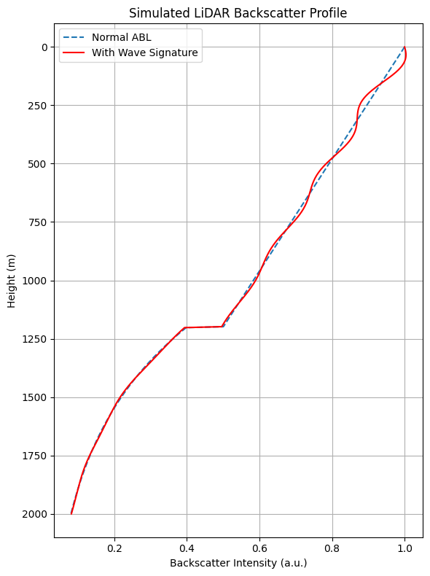

**Figure 1: Lidar Wave Signature Plot**

**4. FUTURE WORK PLAN**

* Select case study days with strong surface heating or convective potential
* Apply wavelet and spectral analysis techniques to isolate wave regions in the LiDAR signal
* Quantify signal fluctuations and correlate with meteorological conditions (if available)
* Visualize vertical and temporal evolution of wave features and turbulence zones
* Validate observed patterns with established theoretical models on convective instability

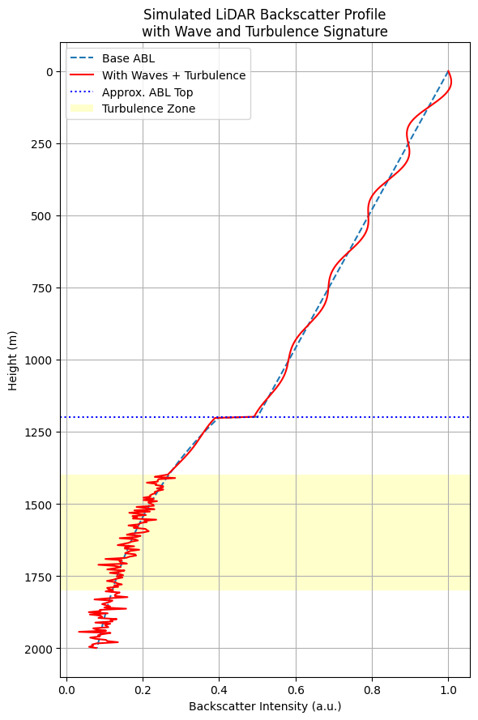

**Figure 2: Lidar Wave Turbulence Signature**

**5. CONCLUSION**

The project sets a novel direction in Atmospheric Boundary Layer research by shifting the focus from traditional height detection to the identification of convection-driven wave activity using LiDAR. The first month’s efforts established a strong theoretical and observational foundation. The upcoming phase will involve deeper signal processing and extraction of scientifically significant wave structures, which may enhance our understanding of boundary-layer instability and early turbulence formation.

**6. REFERENCES**

1. Emeis, S. (2010). *Surface-based Remote Sensing of the Atmospheric Boundary Layer*. Springer.
2. Fritts, D. C., & Alexander, M. J. (2003). Gravity wave dynamics and effects in the middle atmosphere. *Reviews of Geophysics*, 41(1).
3. Tucker, S. C., et al. (2009). Evaluation of boundary layer depth estimates from lidar and radiosonde. *J. Atmos. Oceanic Technol.*, 26(5), 791–807.
4. Boquet, M., et al. (2021). Automatic detection of the atmospheric boundary layer height using LIDAR: Review and evaluation. *Remote Sensing*, 13(3), 457.
5. Sathe, A., et al. (2015). A review of turbulence measurements using ground-based Doppler LiDARs. *Atmospheric Measurement Techniques*, 8(11), 4699–4723.